

**OPERATING SYSTEM LAB**

**TAYYABA REHMAN 49690**

**LAB 12**

**TASK 1:**

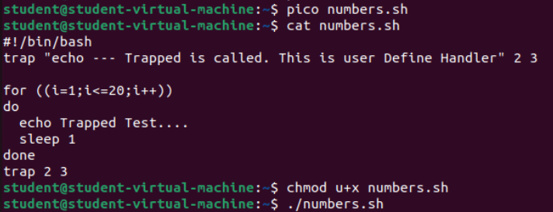

**OUTPUT:**

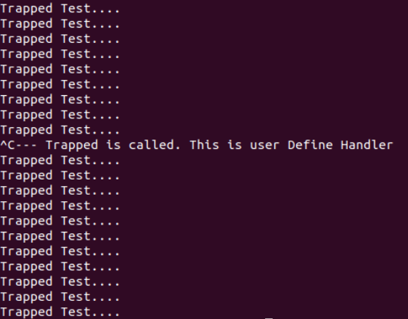

**TASK 2:**

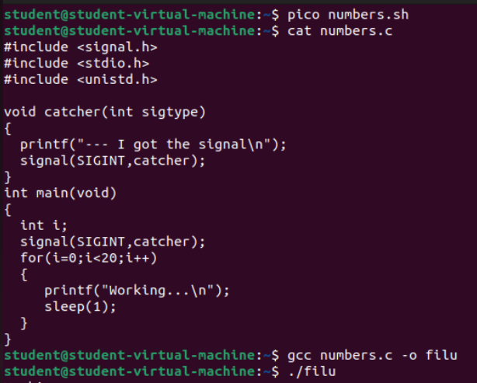

**OUTPUT:**

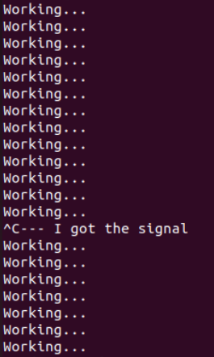

**TASK 3:**

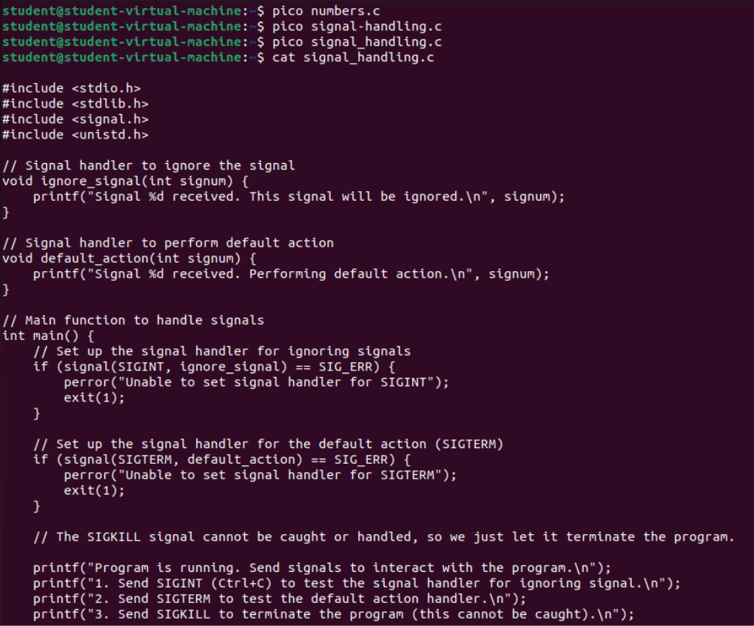

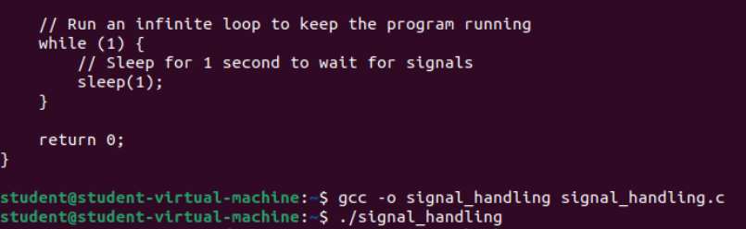

**OUTPUT:**

For kill process we have to open a new terminal and then write following commands:

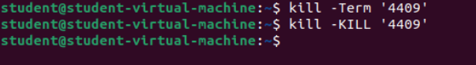

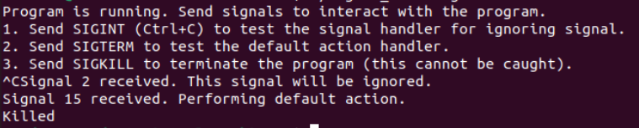

**TASK 4:**

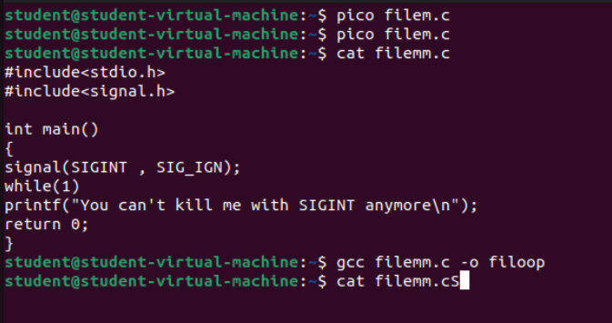

**OUTPUT:**

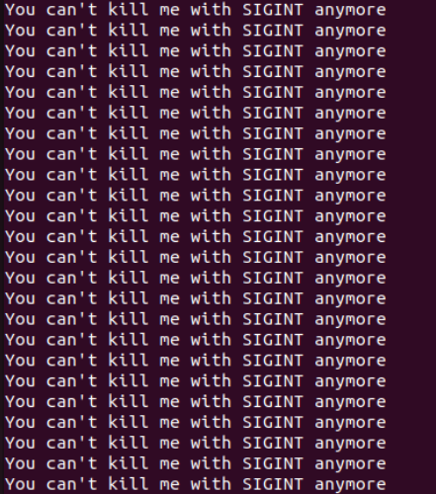

This will not end using ctrl+c command so we have to go to new window and use pidof command to get PID of that process then we have to kill that process using kill -9 PID(of that process).

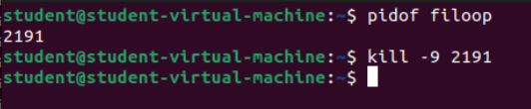

After using this our output will be:

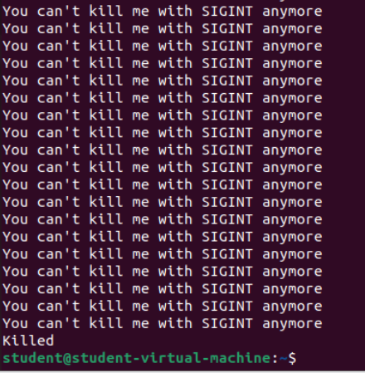

**TASK 5:**

1. **Output:**

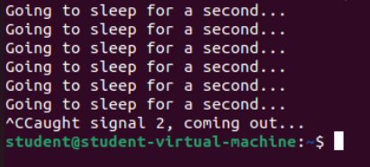

**Code:**

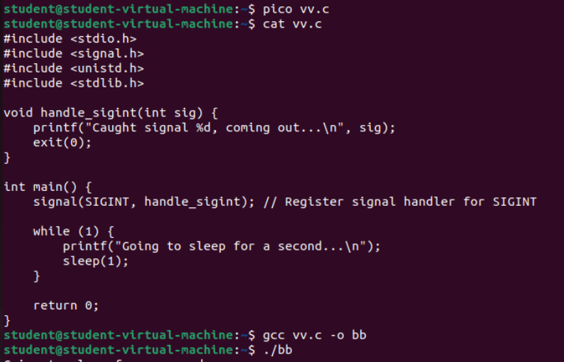

1. **Output:**

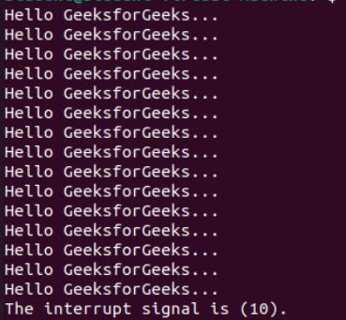

**Code:**

